Java reflection API

1 What are different ways to access **Class<?>**

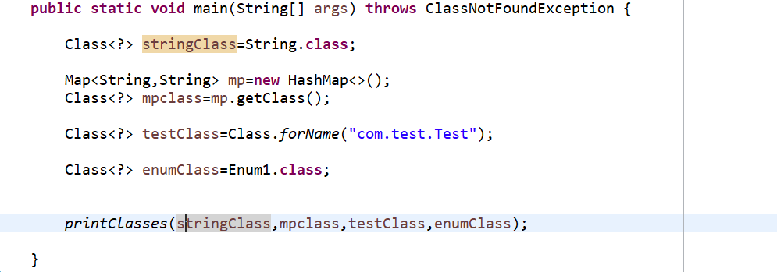

2 . how get package details and interface details of implemented by class ?

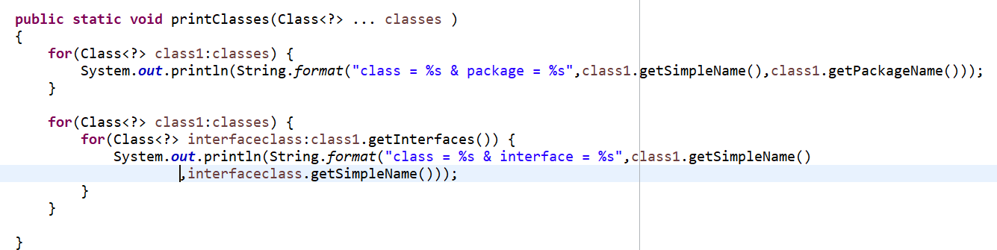

3. How get constructor details

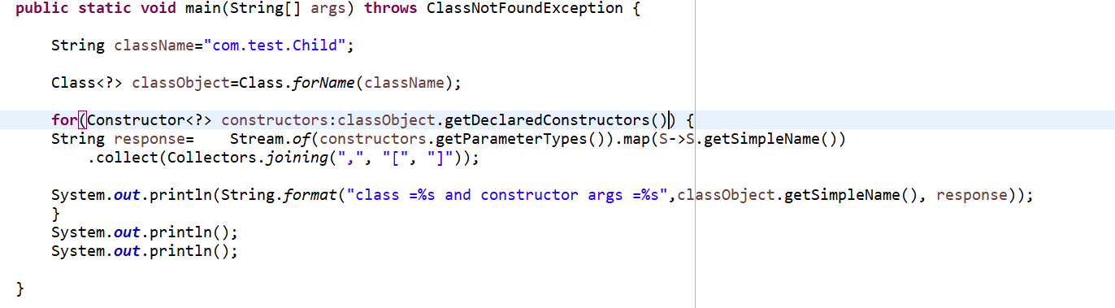

4. creating Object using reflections



5. creating object using private constructor

